Project Development Phase
Performance Test

Date | 3 October 2026
Team ID | SWTID-2026-3373
Project Name | Import Data using Transform Maps
Maximum Marks

Model Performance Testing:
S.No. | Parameter | Values | Screenshot
1 | Data Loaded | Employee spreadsheet data loaded into the Employee Import staging table | 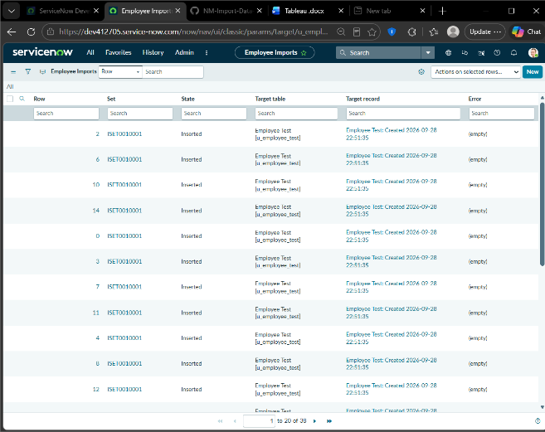
2 | Data Transformation | Transform Map maps Employee Import fields to Employee Test fields | 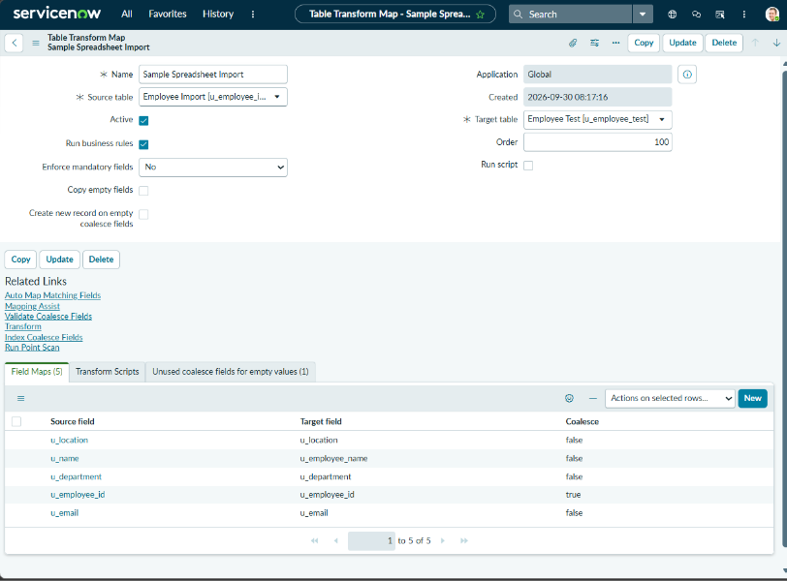
3 | Coalesce / Duplicate Handling | Employee ID configured as Coalesce to update existing records and prevent duplicates | 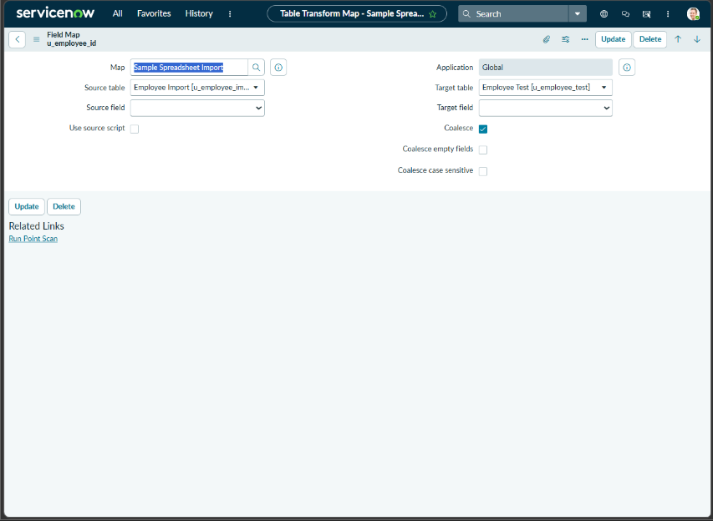
4 | Data Validation | Transform History checked for Inserts, Updates, Ignored records and Errors | 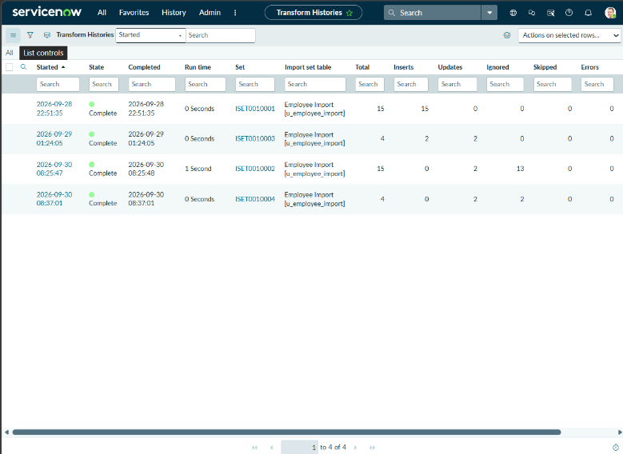
5 | Report Design | 3 reports created: Employees by Department, Employees by Location, Employee List Report | 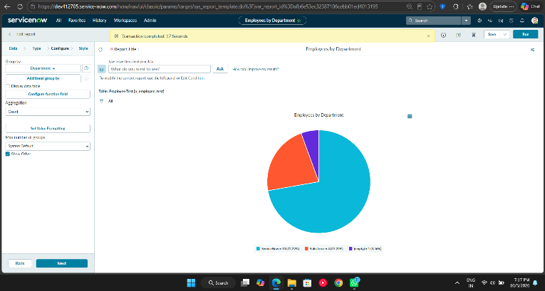
6 | Dashboard Design | Employee Analytics Dashboard containing the employee reports | 